Social Construction of Technology (SCOT)
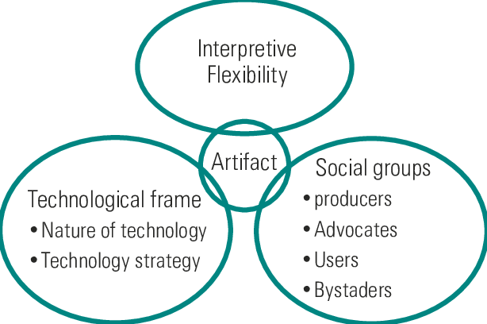

The Social Construction of Technology (SCOT) is a theoretical framework that explains technological development as a social process shaped by human actors, social groups, cultural meanings, and power relations. Developed in the 1980s by scholars such as Wiebe E. Bijker, Trevor Pinch, and Thomas Hughes, SCOT challenges the idea that technology develops in a linear or inevitable manner. Instead, it argues that technologies are socially constructed through interactions among various groups who assign different meanings, purposes, and values to technological artifacts. According to SCOT, technology does not determine society; rather, society plays a central role in shaping how technologies are designed, interpreted, and used.
A key concept in SCOT is interpretive flexibility, which refers to the idea that a single technological artifact can have multiple meanings and uses depending on the social group interacting with it. Different social groups—such as engineers, users, manufacturers, policymakers, and critics—may understand the same technology in different ways and may advocate for different design features. These differing interpretations can lead to debates and conflicts over what the technology should be and how it should function. SCOT emphasizes that in the early stages of technological development, interpretive flexibility is high, meaning that there are many possible technological outcomes rather than one fixed form.
Another central concept in SCOT is relevant social groups, which are the groups of people who share a particular interpretation of a technology. These groups influence technological development by supporting or opposing specific design choices. Over time, as conflicts among social groups are resolved, a process known as closure occurs. Closure refers to the stabilization of a technology when one interpretation becomes dominant and alternative designs are abandoned. Closure does not necessarily mean that the technology is technically superior, but rather that social agreement has been reached. A related concept is stabilization, which describes the point at which a technology becomes widely accepted and its design is taken for granted.
SCOT also highlights the importance of social, cultural, economic, and political contexts in shaping technological outcomes. Technologies reflect the values, assumptions, and power relations of the societies in which they are developed. For example, economic interests may favor designs that maximize profit, while cultural norms may influence usability and accessibility. By focusing on these social influences, SCOT demonstrates that technological change is contingent and that alternative technological paths are often possible but not pursued due to social constraints. Critics of SCOT argue that it may underemphasize material and technical constraints and broader structural forces such as capitalism or state power. Nevertheless, SCOT remains a powerful framework for understanding the social dimensions of technological innovation.

Case Study: The Development of the Bicycle
The development of the bicycle is a classic case study used to illustrate the Social Construction of Technology. In the late nineteenth century, bicycles existed in several different forms, each interpreted differently by various social groups. Early designs such as the high-wheeled “penny-farthing” were favored by young, athletic men who valued speed and excitement. However, this design was seen as dangerous and impractical by women, older riders, and working-class users, who prioritized safety and stability.
These differing interpretations reflect interpretive flexibility, as the bicycle meant different things to different social groups. Manufacturers, responding to the concerns of safety-oriented groups, began developing alternative designs, leading to the introduction of the “safety bicycle,” which featured two equally sized wheels, a chain drive, and improved braking systems. Over time, the safety bicycle gained widespread acceptance as it addressed the concerns of multiple social groups. This marked the process of closure, as the safety bicycle became the dominant and standardized design, while alternative forms gradually disappeared.
From a SCOT perspective, the final design of the bicycle was not the result of purely technical progress but of social negotiation and compromise among competing social groups. The case study demonstrates how technological outcomes are shaped by social meanings, user needs, and cultural values rather than by technological necessity alone.

Questions and Answers
1. What is the Social Construction of Technology (SCOT)?
SCOT is a theory that explains technological development as a social process shaped by human actors, social groups, and cultural meanings rather than as an autonomous or inevitable process.
2. What is interpretive flexibility in SCOT?
Interpretive flexibility refers to the idea that a technology can have multiple meanings and uses depending on the perspectives of different social groups.
3. Who are relevant social groups?
Relevant social groups are groups of people who share a particular interpretation of a technology and influence its design and development.
4. What is meant by closure in SCOT?
Closure is the process by which a technology stabilizes when one interpretation becomes dominant and alternative designs are abandoned.
5. How does SCOT challenge technological determinism?
SCOT challenges technological determinism by showing that technologies are shaped by social choices, negotiations, and power relations rather than determining social change on their own.
6. Why is the bicycle an important example in SCOT?
The bicycle illustrates how different social groups influenced design choices and how social negotiation led to the stabilization of a particular technological form.
7. What are the main criticisms of SCOT?
Critics argue that SCOT may downplay technical constraints and broader structural forces such as economic systems and political power.
8. How is SCOT relevant to modern technologies?
SCOT helps explain how contemporary technologies like smartphones or social media are shaped by user practices, corporate interests, and cultural values rather than being technologically inevitable.

